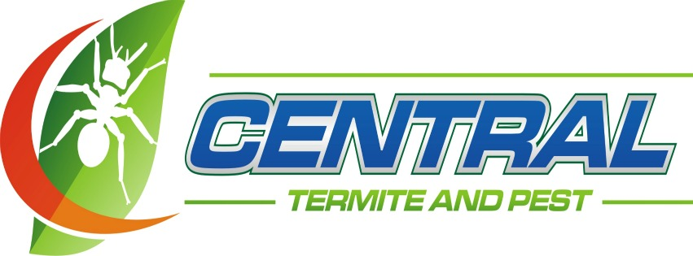

Bed Bug Service Preparation Checklist
Proper preparation for a bed bug treatment is essential to ensure success. You may see some bed bugs in the affected areas after the initial treatment. Although we strive to eliminate bed bugs, please be aware they may be re-introduced immediately after treatment of the home. Following all recommendations will reduce the risk of re-infestation. Central Termite and Pest recommends discarding damaged, heavily infested mattresses, box springs and furniture (wrap in plastic before moving.) Treatment will not be provided until the rooms are completely prepared as set out herein.
N/A
Required
Customer Preparation Of Rooms To Be Treated For Bed Bug Service Includes:
Room(s) not to be re-assembled until no visible evidence of live bed bugs is observed.
Strip beds of all linens and place in bags for immediate laundering. Always use hot, soapy water and dry on high heat (above 140-160F)
Central recommends discarding damaged, heavily infested mattresses, box springs and furniture (wrap in plastic before moving.)
Remove curtains and shades and place in plastic bags for immediate laundering, Always use hot, soapy water and dry on high heat (140-160F)
Detach, but leave in middle of room, all items attached to walls, (pictures, mirrors, light fixtures, outlet covers, cables/switch plates, headboards, etc.),
Loosen the carpet from tack strip at floor/wall junction and/or baseboard around perimeter of rooms.
Vacuum floors using a crack and crevice tool under baseboards.
Vacuum seams and general surface area of all sofa and chair cushions. If sofa contains foldout bed, vacuum that as well.
Remove cushions from sofas and recliners. Turn sofas and chairs upside down and place in middle of room away from walls.
Vacuum seams and general surface area of mattress and box spring. lf sola contains foldout sofa bed, vacuum and remove
mattress from sofa for treatment. DO NOT FORGET UNDERSIDE OF BOX SPRING. Remove and immediately discard vacuum bag.
Remove cloth cover from bottom of box spring and chairs and discard, (Please note: lf cloth covers are still on, Central will
discard after treatment.)
N/A
N/A
Required
Required
Homes & Apartment Homes Hotels
 |  | Remove all clothing from drawers, suitcases and closets for immediate laundering. Always use hot, soapy water and dry on high heat (140-160F) Place in plastic bags and do not remove until no evidence of live bed bug activity is observed. |  |  | Treated room(s) should remain out of service until  no evidence of live bed bug activity Is observed.
 |  | Place all items stored in closets or on shelves such as books, electronics and boxes, etc.in plastic bags and leave in room. |  |  | Place all items stored in nightstands, dressers  or on shelves such as books, €electronics and  phone, etc. in plastic bags and leave in room.
 |  | Arrangements should be made to have your pet treated and all pet bedding cleaned and removed before service date. Always use hot, soapy water and dry on high heat(140-160F) |  |  | Staff should be out of the room during treatment  and remain out for (4) hours after completion.
 |  | People and pets must be removed during treatment and remain out for (4) four hours after completion. |  |  | Comments:
 |  | OTHER:  After Treatment, Customer Agrees to the Following: |  |  | OTHER:
Required
N/A
Clothing in bed bug infested rooms should be laundered in hot water or dry cleaned as appropriate.
Seal all unnecessary cracks and crevices in the room and on housekeeping carts with caulk or appropriate sealant.
Re-attach or replace all furniture, pictures, light fixtures, headboards, etc., to their original location.

Central Termite and Pest Representative:
Customer Signature: Date:

